Golf Your Way Users Guide

*Welcome to Golf Your Way!*

*Please follow the steps below and have fun.*

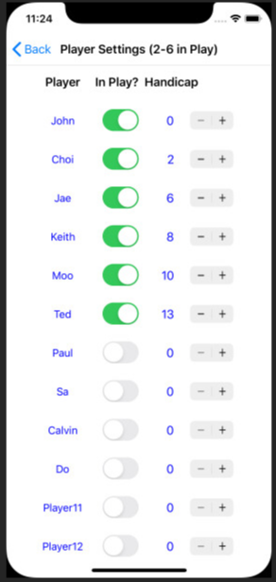

1. **Settings (players, golf course, point options)**
2. Select Players, Courses, Points and then Select Players

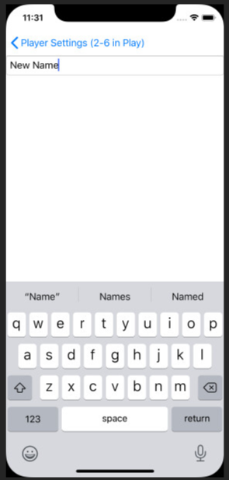

1. Change/Update a player name by selecting a **name,** and type a new name and return .

Limit the number of characters for name to five. If possible, use a short nick name. E.g., Don instead of Donald.

1. Pick the players in the game by sliding on/off switches. You can only pick from two to six players. Switch ON :



1. Update the player handicap using up/down counter.

The minimum handicap is 0 and the maximum handicap is 40.

1. When completed, go back to the **Settings** menu by selecting **< Back**

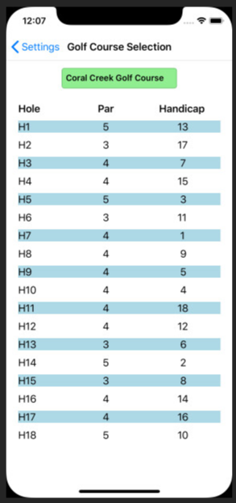

1. Pick **Select Golf Course** menu item.
2. 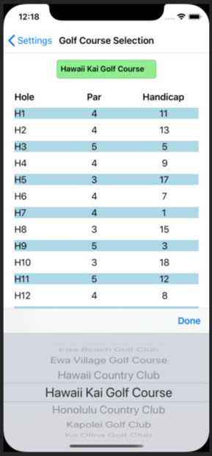Click golf course and pick the desired golf course by scrolling up and down, and then select **Done**. When a new course is selected, Pars and Hole Handicaps will reflect the selected course.
3. Go back to Settings menu by selecting **< Settings** .
4. 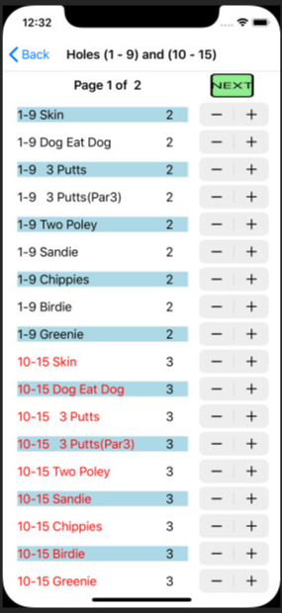 Select Points Setup menu item from the Settings screen.
5. Use

to increment or decrement the points for each option as desired. The minimum is 0 and the maximum is set to 40. Do this for both pages; Page 1 (for holes from 1 to 15) and Page2 (for holes 16-18).

1. To go to page 2, select 
2. Select **< Back** twice to go back to the Main menu. Now you are ready to start recording player’s scores.
3. 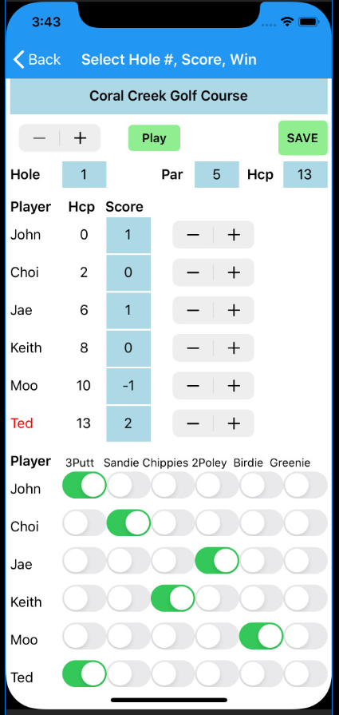**Enter Score**
4. Select the hole number by scrolling hole number with
5. The hole number is initially 1 but will displays the last hole selected when re-entering the score screen.
6. Hole Par and Hole Hcp (Handicap) will show for the selected hole.
7. Upon completion of the hole, update the play scores with adjacent to each player score. ***It is up to the score keeper to use the standard score (i.e. 4 for par 4) or short form (i.e. 0 for par).***
8. For each player, select the winnings (Sandie, Chippies, 2 Poley, Birdie, and Greenie) and 3 putts penalty as appropriate by sliding the switch to ON position.
9. Some player names will be in **RED** indicating this is the handicap hole for them. I.e., their adjusted score will be one stroke less than actual scores.
10. Play button is provided for user to return back to hole in play screen and continue entering scores when user was reviewing previous played holes or future holes. User can always use hole up down switch to go back to the playing hole.
11. 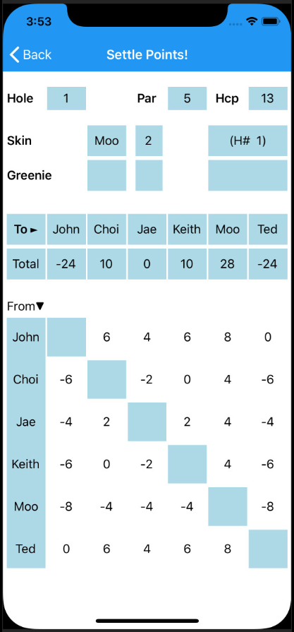Once the scoring is finalized, select to display the **Settle Points!** Screen.
12. If there is a skins winner, the player name and the winning points will be displayed.

If there is a Greenie winner on par 3 holes, the player name and the winning points will be displayed.

1. If an error was discovered or the correction for the current hole is required, the score keeper can modify the scores on the score screen and then re-saved until a new score was saved on the next hole. ***In actual game, if any player tees off for the next hole, all settlements of the current hole become final.*** ***No going back!***
2. Total point under a player is the total winning if it is a positive number or total loss if it is a negative number. The names on the first column shows the players who owes point if the point shows negative number, or who needs to collect points from the player. E.g., Ted lost 24 points total. He needs to pay Choi 6 points, pay Jae 4, pay Keith 8, and Moo 8. John is tied with Ted since both did 3 putts, and adjusted scores are the same, Ted has the handicap on this hole.
3. **Total Points**
4. This screen displays total scores and points up to the last hole played. With this display, players can check their real time point scores while playing. After the game is over, it will display the final tallies.

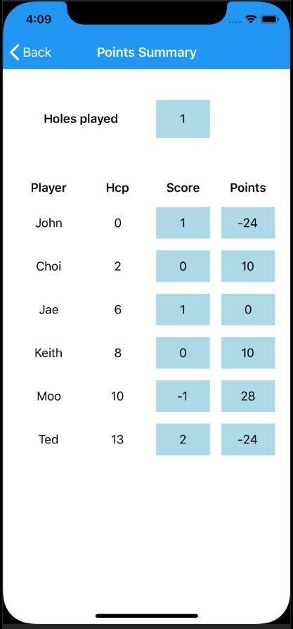

1. **Points History**
2. This screen displays all previous payments on selected hole. You can review all the payment from hole one up to the last hole you played.

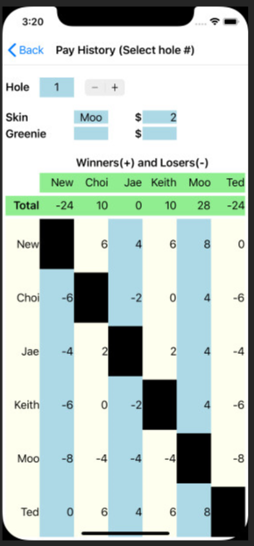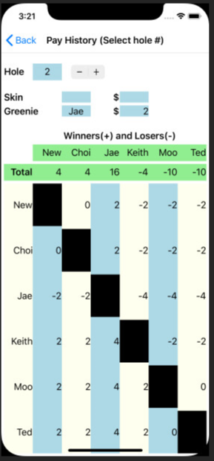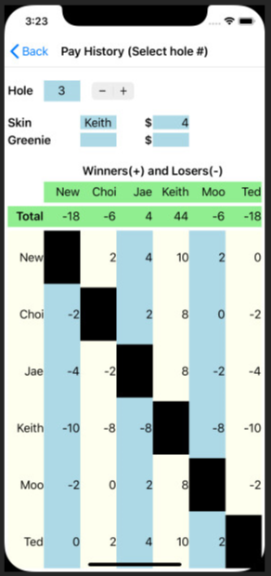

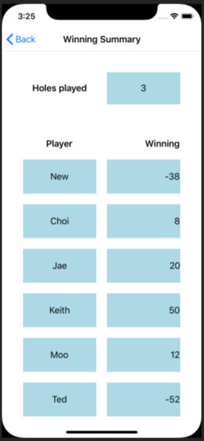

1. **New Game**
2. All changes in the settings are saved in storage and retrieved when the App restarts. Current scores and winnings are only temporary stored while playing the game.

This menu allows the scorekeeper to restart a game by erasing current scores and payments information, and be able to change any settings.  
  
To prevent accidental erase of the scores, User is prompted to make sure the execution.

